Exercises No(1-12)
Name:……………………………………………….…………………………………… MaRk:…………………………………….
A- Grammar:
➲ Choose the correct pronoun:
1- (She – It – He) is my book.
2- I (is – am – are) Nouf.
3- She is (Fatima – Lana – Queen).

***************************************
Put the numbers in order:
12 – 15 – 18 – 13 – 16 – 14 – 17 – 11
_____ _____ _____ _____ _____ _____ _____ _____

***************************************
➲ Complete with (She – He – It)
1- …………. Is Fahad.
2- …………..is my mother.
3- ………….. is my classroom.
***************************************
➲ Read then, Write the question or answer:
1-………………………………………………………………………………………………………………..
I am Fine, thank you.
2-………………………………………………………………………………………………………………..
My name is Fay.
3- How old are you?
………………………………………………………………………
***************************************
➲ Match the capital letters to the correct small ones:
H p
G u
Y r
R y
U g
P h
***************************************

➲ Choose the correct word:
☞

1- (This – That) is a bag.
☞

2- (This – That) is a desk.

1
B- Vocabulary:
Circle the odd word:
1- Door – pen – board – dog.
2- Stop – sit down – open – apple.
3- A – b – c – n.
4- He – She – You – Classroom.
***************************************
Write the correct number next to its item below:
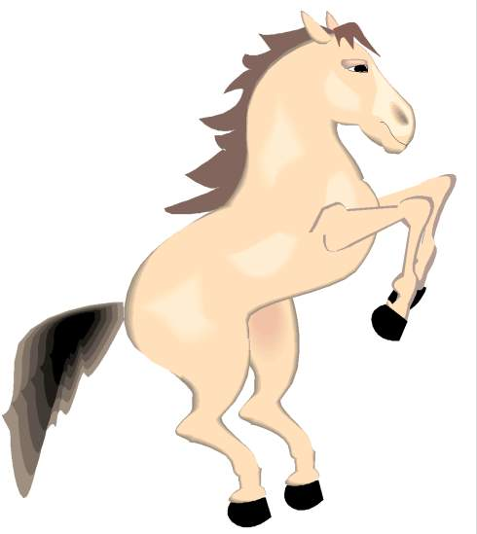
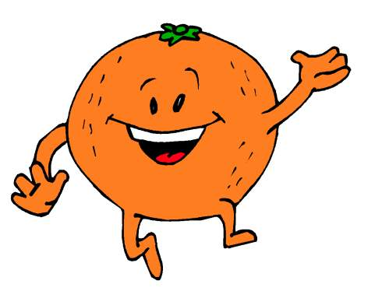

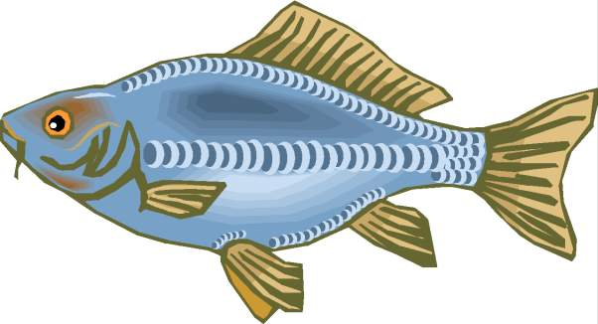


1- Horse. 3- Key. 5- Rabbit.
2- Tomato. 4- Orange. 6- Fish.
 Write the correct name in the square:

________________
_____________
_____________

____________

Give the opposite:
1- Stop X ………………………………
2- Sit down X ………………………….

2

C- Dictation:
☺Write the heard words:
______________________________________________________________________________________________________________________________
..........................................................................................................................................................................................................................................................................................................................................................................................................................................................................................................................
______________________________________________________________________________________________________________________________

D- Hand writing:
This is my family.
_______________________________________________________________________________________________________________________________________
.............................................................................................................................................................................................................................................................................................................................................................................................................................................................................................................................................................
________________________________________________________________________________________________________________________________________

10

2

