In the name of Allah
Kingdom of Saudi Arabia English language

Ministry of education Class : sixth grade
………. Educational zone Time: 90 min
………..elementary school Date : /1/ 1427
Examination for sixth Grade elementary School ( 1426-1427 A.H.)
Name : …………………………………………………………………. | Class:………………….
Q1:Choose the correct answer


1- ( They - he - we ) are schoolboy.


2- This is ( my - his - her ) pencil.

3- The boll is ( on - in - under ) the chair.

4- Ahmad is ( front of - behind - between ) Ali and Hind.
Q2:Complete

1- Is he a teacher ?
Yes,………………
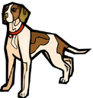
2- Is it a cat?
No,……………….

Q3:Match
1- camel | 2- mouse | 3-eye | 4-soup | 5-tea
 |  |  |  | 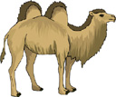
…… | …… | …… | …… | ……
Q4: Fill the missing latter:



c…w | Br..ad
Q5: Copy
I am from Saudi Arabia

