In The Name Of Allah
Second Year
Name : ……………………………………………………………
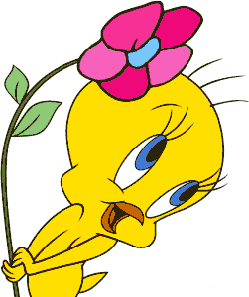
Composition:
3
Read the following passage then answer the questions:

Famous Cities
This Red Sea port is called the Bride of the Red Sea ( Jeddah ). It is located on the Western coast of the Kingdom of Saudi Arabia. The area of the city is about 1,200 square km and the population is more than two million. It is hot and humid throughout the year but it gets better and less humid in winter. The city is famous for its long corniche and the huge fountain which rises about 200 meters from the sea. Tourists enjoy sightseeing the old town with its historical buildings.

Answer the following questions:
1-What is the climate like in Jeddah?
..........................................……………………………………………………………………………………2-What is Jeddah city famous for?
..................................……………………………………………………………………………………....................

Complete these sentences:
1-Jeddah is famous for it's ……………. Corniche.
a-short b-long c-big
2-…………………. enjoy sightseeing.
a-tourists b-teachers c-doctors
3-The Red Sea port is called the Bride of the Red Sea. It is …………..
a-Jakarta b-Jeddah c-Riyadh

Put (T) for the true statements and (F)for the wrong one:
1-Jeddah is located on the Western coast of the Kingdom of Saudi Arabia.( )
2- It is cold and dry throughout the year but it gets better and less dryer in winter.( )
3- Tourists enjoy sightseeing the old town with its historical buildings.

Grammar
A-Choose the correct answer:
5
1-Ahmad is (tall – the tallest – taller than )pupil in the class . 2-You shouldn't ( ate *** eat *** eating ) junk food.
3- Don't (make – made) so much noise.
4-Her project was ( good – better than – the best ) one in class. 5-When ( did *** does ) she go last week ?
6-The blue whale is the ( bigest – biggest ) animal in the world.

7-Did she (played – play) with the computer?
8-Talal is the ( happyest – happiest ) boy in the family.

B. Do as shown between brackets: 1-the world/ Mount Everest/in/ highest/ the/is/mountain/. (Rearrange )
……………………………………………………………………………………………………………….
2-Last week, I ( teach ) my brothers. (Correct)
……………………………………………………………………………………..
3- "Cross the road". (Make it negative)
……………………………………………………………………………………….…
4-Suha cooked rice for her grandfather (Underline the indirect object ) …………………………………………………………………………………………..
5-The Green Mountain is 3000 meters high. (Make a question using How)
……………………………………………………………………………………………………………………………..
6-……………………………………………………………………? ( make a question with When)
Amal got up at 5 o’clock yesterday.
Informational Questions:
Answer these questions:
1-What is the fastest animal in the world?
4
…………………………………………………………………………………………………………………………
2- What should you do when you are ill?
………………………………………………………………………………………………………………………
3-Where did you meet your first friend?
………………………………………………………………………………………………………………….
4-What are the main directions ?
………………………………………………………………………………………………………………………………………………………………………..

Vocabulary
A-Give the opposite:
Happy*………….. Left*……… More*…………… Thin*……………..
5

B-Choose the correct answer:
1- Exhibits means:
(Places teachers can go to-Things for everyone to see-flags you can buy).
2-We can buy medicine from the…
(pharmacy *** desert *** camp)
3- When my brother got swollen ankle ,he needed…..
(aspirin *** cough medicine *** honey).
4-Makkah is the ( most crowded – least crowded ) city in Saudi Arabia.

C-Write each word under the right picture:

((Swollen ankle -Eiffel Tower -Food Poisoning -Don't park -Cheetah-Friendly))
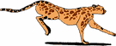
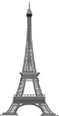
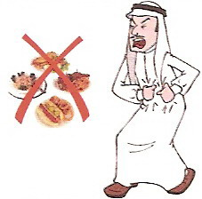
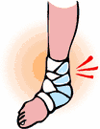


……………….. ………………………… …………………… ……………………. ……………………………… ……………………

Spelling
4
A-Write the missing words:
Before test, You……….. sit in a …………… place to study.Also,You must ………….
Everything you ………… with you.In the test,You should ……………… over the test …………….first.
This will help you …………. ……………..
B-Choose the right spelling:
1-Afr…….id 2-Naught…… 3-Tal……tive 4-….nt

Hand Writing
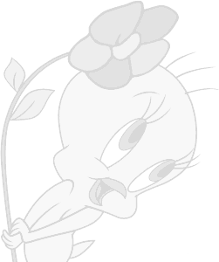
4

The blue whale is the biggest animal.

Jeddah is called the Red Sea port.



T.LORA

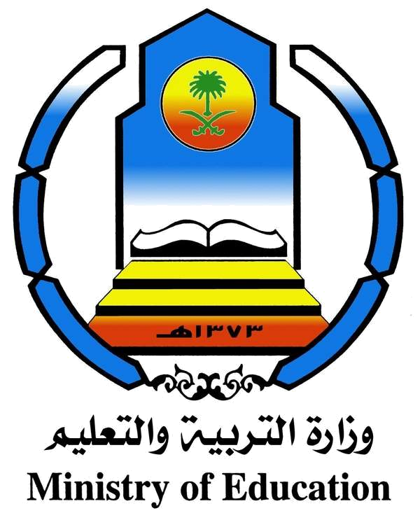

Kingdom of Saudi Arabia Time:………… The Ministry of Learning and Education Date:………
…………Intermediate school
Second Year Exam(Second Term)

Name:………… ………………….. …………….
السؤال | الدرجة رقما | الدرجة كتابة | اسم المصححة | توقيعها | اسم المراجعة | توقيعها
Composition
Grammar
formational Questions
Vocabulary
Spelling
Handwriting
Evaluation
المجموع

