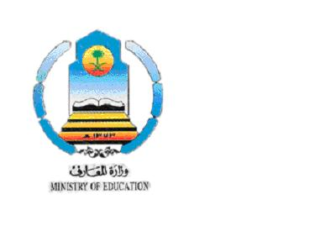
Kingdom of Saudi Arabia Holy capital educational zone
Ministry of Education Alyamamh Int. school
اختبار نهاية الفصل الدراسي الثاني لعام 1425 / 1426 هـ
المادة اللغة الإنجليزية
الدور الأول
الصف الثاني المتوسط
الزمن: ساعة ونصف
Total | Oral | 4TH | 3RD | 2ND | 1ST | Q
Mark
number
Mark
written
 |  |  |  |  |  | Correction

30

المجموع/

اسم الطالب: .................................................................... الصف: ........................ رقم الجلوس: ...............................

Q1) Read the passage then answer the questions from the passage.
3

Map Reading
There are different kinds of maps: like the world map, city map, road map, street and house maps. We use directions on a map to show us places. The main directions are east, west, north and south. A compass rose is used to see the directions.
Maps also show size, climate and physical features such as rivers, mountains and deserts of a country. Signs or symbols are used to show things on a map. Symbols place words by pictures to make the map easier to understand. These symbols are shown in a small box called the 'key' or 'legend' given on the side of a map.
A) Name two kinds of maps.
……………………………………………………………………………………………………
B) What does the map 'key' tell you (choose one answer )
a. The names of countries.
b. The meanings of the symbols on the map.
c. The colours of flags.

Q2) Answer the following questions.
12

A) Rewrite the following sentence twice:
Jeddah is called the Bride of the Red Sea.
………………………………………………………………………………………………….
………………………………………………………………………………………………….
B) Choose the missing letter to complete the vocabulary.
1) go s__raight ( f _ t _ n )
2) mem__rable ( o _ i _ a )
3) __rowded ( k _ c _ f )
4) pyra__ids ( n _ e _ m)
اقلب الورقة turn the sheet
C) Choose the correct answer
1) The colors of the Saudi flag are ( green & white – red & green – red & white)
2) The last day of the week is ( Saturday – Friday – Sunday )
3) England is in ( Africa – Asia – Europe )
4) The capital of Saudi Arabia is ( Riyadh – Makkah – Jeddah )

Q3) Do as shown between brackets:
5
1) When did you ( went – go – gone ) to Taif ? [ choose a verb ]
2) Salim spent the holiday in Syria. [ circle the D.O and underline the I.O ]
3) Jeddah is ( hot – hotter – hottest ) than Taif [ choose the correct word ]
4) long / the / ? / River / How / Nile / is [ put in correct order ]
………………………………………………………………………………….
5) You should study ( good – well – goodly ). [ choose the correct word ]

Q4) Answer the following questions
5

A) write the correct word under each picture.

diamond dizzy cheetah circle

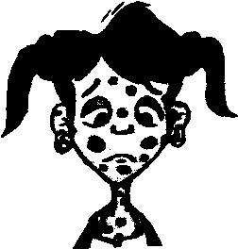


……………………... ……………………... ……………………...

B) Write the opposites of the adjectives.

big # ……………………… late # ………………………
happy # ……………………… good # ………………………

انتهت الأسئلة the end of questions

