Q1:

7
- Comprehension:
Read the following passage then answer the questions:
Omar and his father flew to Riyadh last Thursday. Omar
got up at twenty-past five. After breakfast, he and his father drove to airport. They took off at quarter to twelve. They had
lunch on the plane. In Riyadh they visited some friends. They
went shopping and bought some clothes. They came home at
half nine.
a. Answer these questions
1-When did Omar get up ?

b. Put (  ) or (  ).
1- Omar and his father visited some friends in Riyadh. ( )
2- Omar and his father came home at half ten. ( )
c. Choose the correct answer:
1- They took off at quarter to ………………………………
3
- eleven  - twelve  - nine
2- They had ………………………. on the plane.
❑ - dinner  - breakfast  - lunch
_________________________________________________________________________

- General question : -
answer:
- What is your favourite colour ?
………………………………………………………………………………………………
2 - what is your favorite colour ?
4
……………………………………………………………………………………….……………………
_____________________________________________

Q2:

10
- Grammar :-
- Choose the right :-

1- What ( does , do, did ) you look like?
2- You are a students. They are ( his , hers , your ) bags.
3- I am ( read , reads , reading ) now.
4- ( We , It , He ) are buying a blouse.

- Do as shown in brackets:-
1 – She ( has) got a headache. “ correct the verb “
……………………………………………………………………………………………….
5

2- What _ _ _ _ _ _ _ _ _ _ _ _ _ _ _ _ _ _ _ _?" ask "
It is beautiful.

- Vocabulary:
1. Match the words with the pictures : -
1-
2- 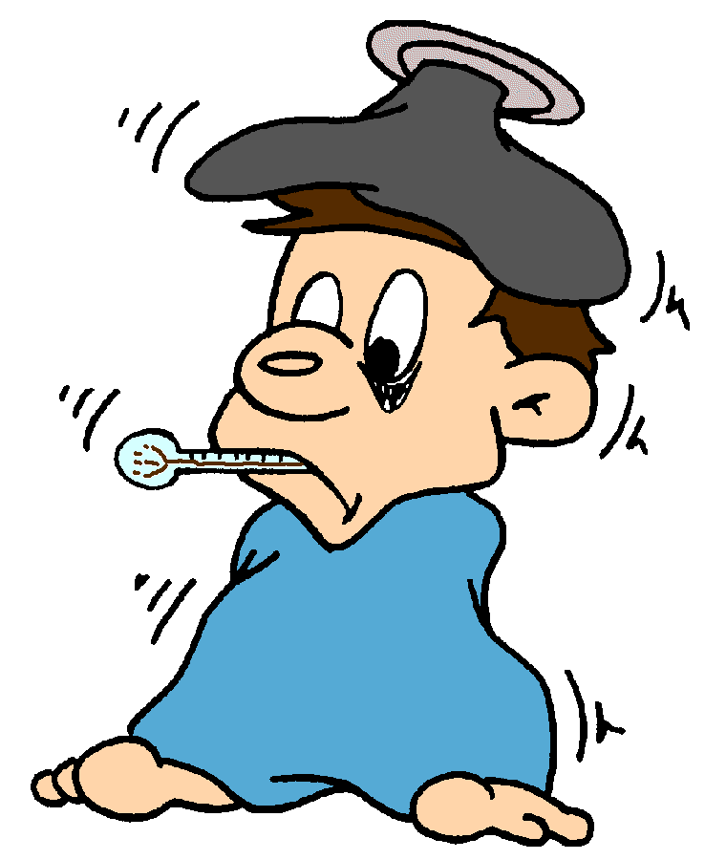
3-
4-
a- teeth ……………

b- fever ……………

c- Cloudy ………………

d- jacket ………………

2- Give the opposite:-

new×_ _ _ _ _ _ , cold × _ _ _ _ __ _ ,
expensive× _ _ _ _ _ _ short×_ _ _ _ _ _ _
5

___________________________________________

8
Q3-

- Dictation :-
1-Fill in the missing letters:
Sami is f__t and sho__t.
I have got b__ack ha__r.
My brother’s e__es are s__all.
How mu__h do you weigh? I am 45 kil__s.
4

_____________________________________________________

Handwriting:
Write this sentences twice:

4

