Unit : 9 ( My clothes )

A - What do you wear at home ?

…………………………………………………………………………………………………………

B - What do you wear at school ?

………………………………………………………………………………………………….............

________________________________________________________________________________________________________

C - Choose :

1 - Ahmad is ( wear - wear - wearing ) his thobe .
2 - Fatimah is ( carrying - carry ) a briefcase .
3 - They ( am - is - are ) buying a scarf now .
4 - I ( am - is - are ) wearing a blue shirt .
5 - What size is it ? - It is ( beautiful - green - medium ) .
6 - What is it like ? - It is ( small - 150 riyals - beautiful ) .
7 - The scarf is ( hers - her ).
8 - It is ( my - mine ) uniform
9 - ( Whose - Where ) book is this ?
10 - What ( size - colour ) are they ? - They are white and black .

_____________________________________________________________________________________________________________

D - Give the opposite :

big X ………… old X …………
cheap X ……………. ………… X long

______________________________________________________________________________________________________________

E - Do as shown between brackets :

1- He is sleeping now . [ Change to : Negative ]

………………………………………………………………………………………………………………………..

2 - They are not buying shirts . [ Change to : Affirmative ]

…………………………………………………………………………………………………………………………

_______________________________________________________________________________________________________________

F - Fill in the missing letters : ( e - r - u - c - b )

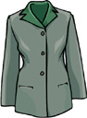
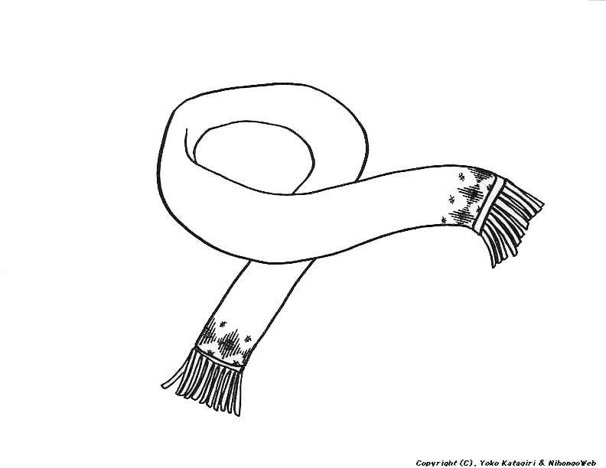
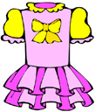
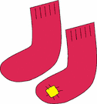

blo _ se so _ ks _ elt d _ ess s _ arf

Unit : 10 ( My Body )

1 - What colour are your eyes ? ……………………………………………………………………………………………

2 - What colour is your hair ? …………………………………………………………………………………………...

3 - Is it important to eat healthy food ? ………………………………………………………………………….........

4 - Do you take medicines without going to the doctor ? …………………………………………….......

_______________________________________________________________________________________________________________

A - Choose :

1 - ( How - What ) tall are you ?
2 - How much do you weigh ? - I`m 45 ( centimeters - kilos ).
3 - I ( have got - has got ) a headache .
4 - She ( have got - has got ) a sore throat .
5 - ( Go - Take ) some aspirin .
6 - They ( have - has ) got the flu .

________________________________________________________________________________________________________________

B - Match :
1 - How old are you ? ( ) He is 55 kilos.
2 - How tall is your sister ? ( ) I`m twelve .
3 - How much does your ( ) She is one metre 30 .
brother weigh ?
________________________________________________________________________________________________________________

C - Give the opposite :
fat X ……….. tall X …………

young X ……….. straight X …………..

____________________________________________________________________________________________________________

D - Fill in the missing letters : ( o - y - n - k - f - e )

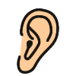

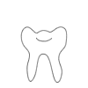
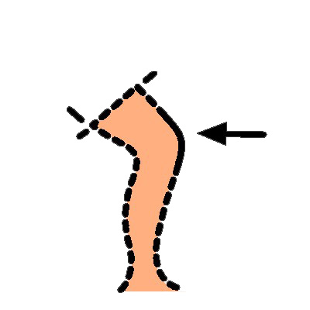
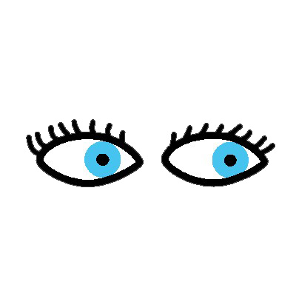

_ ar _ ace t _ oth _ nee e _ e ha _ d

Unit : 11 ( Shopping )

A - Why do people go to the malls ?

……………………………………………………………………………………………………………………………………………………………..

_____________________________________________________________________________________________________________

B - Choose :

1 - How ( much - many ) pens do you have ?
2 - How ( much - many ) are they ?
3 - How ( much - many ) does it cost ?
4 - How many ( books - tea ) does she have ?
5 - How much ( papers - money ) do you have ?
6 - How much ( is - are ) the pen ?

______________________________________________________________________________________________________________

C - Write where can you find these items :

( milk - plants - jacket - books - aspirin )

Flower shop Book shop Pharmacy Supermarket Dress shop

…………………. …………………. …………………. …………………….. ……………………

______________________________________________________________________________________________________________

D - Make questions :

a - ……………………………………………………………………….. ?

b - I want three shirts .

a - ………………………………………………………………………… ?

b - They are sixty – four riyals .
_____________________________________________________________________________________________________________

E - Put the words in the box below under the correct column :

milk - shirts - books - water - pens - money - juice

How much How many

………………………………. ……………………………....

………………………………. ……………………………….

……………………………….. ………………………………..

………………………………. ………………………………

Unit : 12 Revision

A - Choose from the verbs in the box to complete each sentence :
are - have - wearing - has - carry - is

1 - Mohammad is ………………………… a white thobe .
2 - Muna ……………………….. got a red coat and a scarf .
3 - Sami`s trousers ………………………. blue .
4 - ……………………. this a new jacket ?
5 - They ………………………. black bags .

______________________________________________________________________________________________________________

B - Put ( T ) or ( F ) :

- Sweets are good for your teeth . ( )
- Water helps your body . ( )
- Sleep early every night . ( )
- Missing breakfast is bad for your health . ( )

______________________________________________________________________________________________________________

C - Choose the correct response :

1 - What size is it ? 2 - I have got a headache .
a - It`s a medium . a - Take some aspirin .
b - It`s 1 meter . b - I have a sore throat .
c - It`s yellow . c - What`s the matter ?

3 - Whose dress is this ? 4 - How much sugar do you take ?
a - It`s beautiful. a - Two , please.
b - It`s mine. b - There are two.
c - It`s black. c - It`s two.

Unit : 13 ( Day by Day )

1 - How many hours do you sleep ?

I sleep for 8 hours .

2 - Do you get enough sleep on weekdays ?

Yes , I do .
______________________________________________________________________________________________________________

A – Put ( ) or ( X ) :

- It is polite to make people wait for you . ( )
- Time is important . ( )
- We should use time well . ( )
______________________________________________________________________________________________________________

B - Use " Prepositions of time " to fill the spaces below :
Prepositions of time : [ in - on - at ]

1 - The game starts …………………. 6 p.m.
2 - I eat my breakfast ……………….. the morning .
3 - It is ……………….. 7 o`clock .
4 - Are you busy ……………….. Monday evening .
5 - Our dinner will be serve ……………….. night.
6 - I will see you ……………….. Thursday morning .
_______________________________________________________________________________________________________________

C - Arrange : ( Monday - Friday - Wednesday - Saturday - Sunday - Thursday - Tuesday )

........................... - …………………… - ………………….. - ………………….. - ………………….. - ………………….. - …………………...
________________________________________________________________________________________________________________

D - Complete : - Today is ................................ / Yesterday was ……………………..

Tomorrow is …………………………
_______________________________________________________________________________________________________________

E - Answer : - What time is it ?

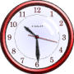

- It is ………………….. - It is ………………….. – It's ………………… - It's ………………….

……………………………… ………………………………. ……………………………. …………………………….
_______________________________________________________________________________________________________________
F - Find the odd word :

1 - Days of the week [ Sunday - Tuesday - Time - Wednesday ]
2 - Meals [ breakfast - midnight - lunch - dinner ]

Unit : 14 ( Food )

1 - What is your favourite food ? - My favourite food is …………… [ apple - meat - rice …]
2 - What is your favourite drink ? - It is .......................... [ juice - water - milk - cola ….]
3 - What kind of food do like for breakfast ? - I like ……………. [ eggs - cheese - fruit ….]
4 - Do you make a list before buying things ? - Yes , I do . / - No , I don't .
______________________________________________________________________________________________________________

A - Use : ( some / any )

1 - Are there …………………… eggs in the fridge ?
2 - There are ………………….. eggs .
3 - There are not …………………. oranges .
4 - Rula has …………………. carrots .
______________________________________________________________________________________________________________

B - Tick the chart :
Drink | Food
 |  | milk
 |  | bread
 |  | orange
 |  | water
 |  | cake

_____________________________________________________________________________________________________________

C - Put the items in their suitable places :

carrots - rice - bread - eggs - banana - meat - apples - oil

countable
1- : ……………………… / …………………… / ……………………. / ……………………

……………………… / ............................ / ……………………. / ……………………

uncountable
2- : ……………………… / …………………… / ……………………. / ……………………

……………………… / ............................ / ……………………. / ……………………

______________________________________________________________________________________________________________

D - Which words go together ? Tick the chart :
bottle | glass | piece | pot | cup
 |  |  |  |  | tea
 |  |  |  |  | cheese
 |  |  |  |  | milk
 |  |  |  |  | bread

E - Do as shown between brackets :

1 - We drink milk . [ Use : always ]

…………………………………………………………………………………………………………………………………

2 - I am late for school . [ Use : never ]

………………………………………………………………………………………………………………………………….

3 - There are some apples on the table . [ Change to : Negative ]

………………………………………………………………………………………………………………………………….

4 - There are not any carrots in the fridge . [ Change to : Affirmative ]

………………………………………………………………………………………………………………………………….

Unit : 15 ( Countries )

1 - Where are you from ? - I am from Saudi Arabia .

2 - What is the capital city of your country ? - Riyadh .

3 - What is your nationality ? - I am Saudi .

4 - What language do speak ? - I speak Arabic .
_______________________________________________________________________________________________________________

A - Put ( T ) or ( F ) :

- Learning other languages is important . ( )
______________________________________________________________________________________________________________

B - Give the opposite :
sunny X …………………… cold X ……………………
______________________________________________________________________________________________________________

C - Arrange :
February - April - March - June - May - July - October

January - August - December - September - November

1 - ……………………….. 4 - ………………………… 7 - …………………………. 10 - ……………………………
2 - ……………………….. 5 - ………………………… 8 - …………………………. 11 - ……………………………

3 - ……………………….. 6 - ………………………… 9 - …………………………. 12 - ……………………………

_______________________________________________________________________________________________________________

D - Find the odd word :

1 - The for seasons [ spring - summer - Japan - autumn - winter ]
2 - Countries [ Makkah - India - Britain - Italy - France ]
3 - Months [ January - north - July - September - October ]
4 - Languages [ Arabic - Japanese - French - Italian - sunny ]
5 - Directions [ east - cold - north - south - west ]
6 - Cities [ Baghdad - Cairo - London - Makkah - spring ]
_______________________________________________________________________________________________________________
17th 1st 20th 18th 14th 3rd 2nd
E - Match :

……… Second ……… Fourteenth ………. Seventeenth

……… Twentieth ……… F irst ……… Eighteenth

……… Third

Unit : 16 Revision

A - Fill the spaces :

Countries
Nationalities

Saudi Arabia ………………………………

……………………………. Italian

Britain ……………………………..

…………………………… French

___________________________________________________________________________________________________________

B - Choose the correct answer :

1 - What time is it ? 2 - Where are you from ?
a - On Saturdays. a - Riyadh is the capital.
b - In the morning. b - I speak English.
c - It's five o`clock. c - I'm from Saudi Arabia.

3 - What's the weather like ? 4 - What do you usually have for breakfast ?
a - I enjoy the cold weather. a - Milk is good for you.
b - It's hot and humid. b - Eggs and bread.
c - Spring is my favourite season. c - There are some apples.

_____________________________________________________________________________________________________________
First Eighth Third Seventh Sixth Ninth
Fourth Second Tenth Fifth

C - Arrange :

1 - …………………. 2 - ………………….. 3 - ………………………. 4 - …………………… 5 - ……………………..

6 - …………………. 7 - ………………….. 8 - ………………………. 9 - …………………… 10 - ……………………
_________________________________________________________________________________________________________________

D - Match :

pot piece glass cup bottle

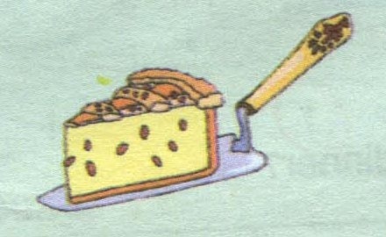
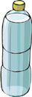

………………….. ………………….. ………………….. …………………. …………………..

COMPLETION REVISION FOR FRIST GRADE.
NAME:……………………………………………………………………………..
1/ Comprehension
Salma is 45 years old. She is a teacher. She goes to work by bus. She likes writing and reading books. She likes ice cream and pizza. She is wearing a blue dress, black shoes and whit headscarf. She is carrying a green books and grey case
A. Answer these questions in complete sentences:
1. How old is Salma?
………………………………………………………………………………..
2. What is she carrying?
…………………………………………………………………………………
. Choose the right completion: B
1. She is ………………… (a. a teacher. - b. a nurse. - c. an engineer.)
(a. ice cream. - b. juice. - c. cola) 2. She like ……………….
C. Decide if the following statements are true ( ) or false ( ).
1. She is wearing a blouse and skirt ( ) 2- She likes writing and reading books. ( )
-----------------------
Q2/ General Questions A- Answer these general questions:
1- What is the capital city of your country?
It ………………………………………………………………………………….
What is your favourite food?
My……………………………………………………….
2- How many days are there in the week?
There ……………………………………………………………………………
b- Choose the correct answer:-
1. How much do you weigh? a) I am 40 kilos. b) My size is medium. c) I am 145 centimeters.
2. What does she look like? a) She is sleeping. b) She is tall and thin. c) She has cold.
3-When you want milk and juice go to? a) Dress shop. b) Shoe shop. c) Supermarket.
4-What's the weather like in Saudi Arabia? a) Its snowy. b) Its sunny. c) Its rainy.
-----------------------------------------------------
Q3/ Grammar A / Choose the correct answers:
1- Maha (are- has- is) 130 cm.
2- Ali (have- has- is) got brown hair.
3- How (many- any- much) coffee is there?
4- I (writes- write- wrote) a short story.
5- This is your pen. The pen is (yours- hers- ours).
6- They play football [in-on-at] Monday.
7- Are there any oranges in the fridge? No, there aren't (some- any- few) oranges.
8- Where (is- am- are) she from?
B/ Do as shown between brackets:
1- ………………………… is it? His shirt is 50 riyals. (Make a question).
2- Ahmad is (play) ……………………… football everyday. (Correct the verb).
3- At school I ……………… read Quran. (Use frequency Adverb)
4-……… Mangos ……….. Water (Put C for countable and U for uncountable)
ؤيييييييييلييلبللؤؤؤؤؤؤيؤؤcCؤؤؤؤCcccccCCccccccccccdffبلاؤؤؤؤؤ
ؤيييييييييلييلبللؤؤؤؤؤؤيؤؤcCؤؤؤؤCcccccCCccccccccccdffبلاؤؤؤؤؤ
5- is / a computer/. / using / she (Re arrange the sentence).
…………………………………………………………………..

Q4/ Vocabulary A/ Circle the odd words:
1- Body part (ear – leg – teeth – shoes – face).
2- Drinks (chicken – juice – water – coffee – tea).
-------------------
B/ Give the opposite:
1-Young = ………………… 2- thin =……………………… 3 – short = ……………………… 4-expensive = …………………..

C / Match A with B :
(A) (B)
1- Furniture shop ( ) toothache
2 – Illnesses ( ) green
3 – Colour ( ) sofa
4- Clothes ( ) eyes
( ) dress
-------------------------
D/ What time is it?
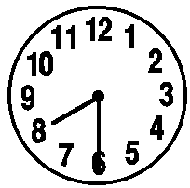 | 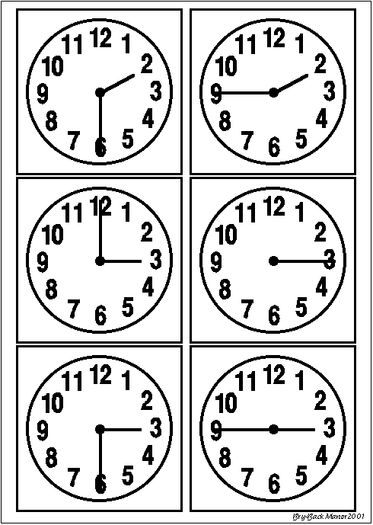
E/ Match the pictures with the right word:
Shoe shop - escalator - hand - nose - skirt
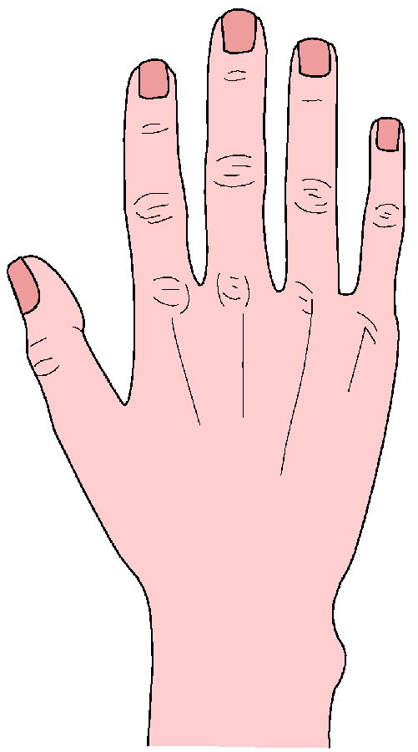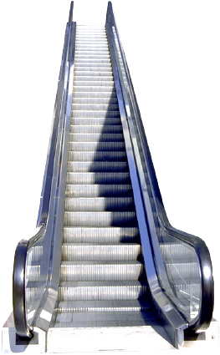
................. .................... .......................... .....................
Spelling A – Fill in the missing letters:
1- Nouf has got blue ey…s and cu…ly hair. 2- Heada…he and fe…er are kinds of illness.
3-I have brea…fast at 7:00 am, lu…ch at 2:15 Pm and dinn…r at 10:00 pm.
4- In sum…er Jeddah is h…t and h…mid.
B – Circle the right spelling:
1- muoth - mouth – mouht. 2- knee – nkee- keen.
3- dark – drak – deerk. 4- scoks – soocke – socks.
5- pherrmaci –pharmacy – perhmacy. 6- butcher's – betcheer's – buthcer.
---------------------------------------
Hand writing: A-Write the following sentences:
1-

G☺☺d Luck Sweet Girls ☺☺☺
Teacher/ Romanciah.

